**COSMECTICS STORE MANAGEMENT**

Developed By:

P.Gowtham Sagar

Sree Vidyanikethan Engineering College

Department Of CSSE-Final Year

21121A2936

**ABSTRACT**

This project presents a comprehensive Cosmetics Store Management system designed to streamline operations, enhance customer experience, and optimize inventory managementwithin the cosmetics retail sector. The system integrates various functionalities, including product management, sales tracking, customer relationship management, and reporting features.

The objectiveof this projectis to develop an efficient platform that enablesstore owners to manage their inventory effectively, track sales trends, and maintain customer records seamlessly. By implementing a user-friendly interface, the system aims to facilitate easy navigation for both staff and customers, ultimately improving service quality and operational efficiency.

Through this project, we also highlight the importance of data analytics in the cosmetics industry, providing insights that can drive marketing strategies and improve customer satisfaction. Overall, the Cosmetics Store Management system serves as a vital tool for retailers seekingto thrive in a competitive market while ensuringan enhanced shoppingexperience for their customers.

**INDEX PAGE**

|  |  |  |
| --- | --- | --- |
| TOPICS |  | PAGES |
| 1.Creation salesforce org |  | 04-06 |
| 2.Object |  | 07-11 |
| 3.FieldsAnd RelationShip |  | 12-15 |
| 4.Page Layouts |  | 16-17 |
| 5.The Lightning App |  | 18-20 |
| 6.Profile |  | 21-22 |
| 7.Setup Roles |  | 23-25 |
| 8.Users |  | 26-27 |
| 9.User Adaption |  | 28-31 |
| 10.ImportData |  | 32-35 |
| 11.What Are Reports? |  | 36-39 |
| 12.Dashboards |  | 40-41 |

**1.Creation Salesforce Org**

Logging into SmartInternz Skill Wallet:

* + 1. **Visit**
    2. **The SmartInternz website**: Go to [SmartInternz.](https://smartinternz.com/)
    3. **Locate the Login Option**: On the homepage, find the login or sign-in option.
    4. **Use your credentials**: Enter the email and password you registered with. If you're using a platform-linked account (e.g., Google, LinkedIn), use the corresponding option to sign in.
    5. **Navigate to the Skill Wallet**: Afterlogging in, go to your dashboard or profile section where you should find "Skill Wallet" or "Guided Projects" listed.

Accessing Guided Projects:

* + 1. After logging in, navigate to the "Guided Projects" tab or sectionon the SmartInternz platform.
    2. Here, you should be able to see any projects you’ve been assigned or those you’ve enrolled in.
    3. Click on any project to view the details, guidelines, and resources you need to complete it.

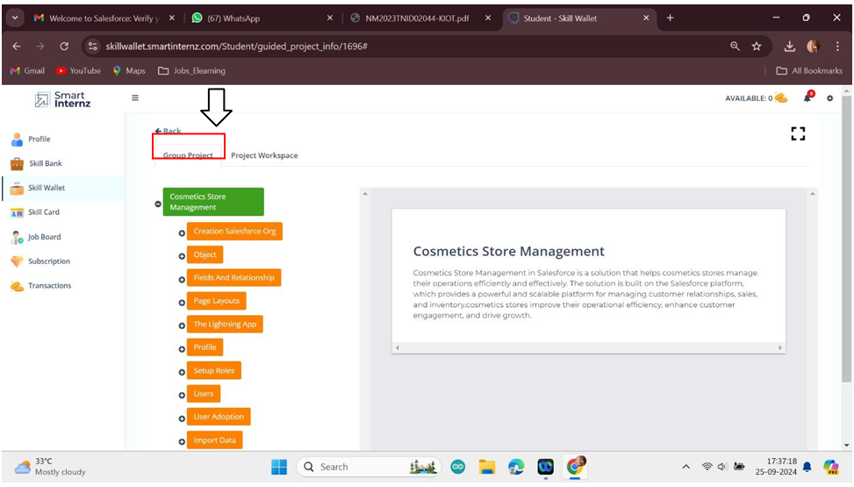

**Creating DeveloperAccount**

Creating a developer org in salesforce.

* + 1. Go to [developers.salesforce.com/signup.](https://developer.salesforce.com/signup)
    2. Click on sign up.
    3. On the sign up form, enter the followingdetails :
       1. First name & Last name
       2. Email
       3. Role : Developer
       4. Company : CollegeName
       5. County : India
       6. Postal Code : pin code
       7. Username : shouldbe a combination of your name and company.

This need not be an actualemail id, you can give anything in the format

:username@org.com

Click on sign up after fillingthese.

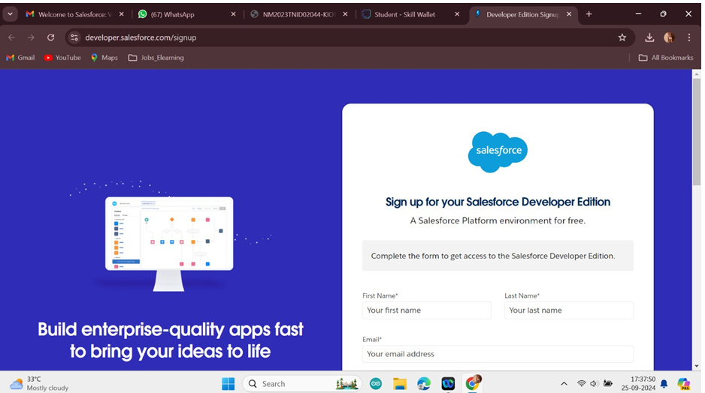

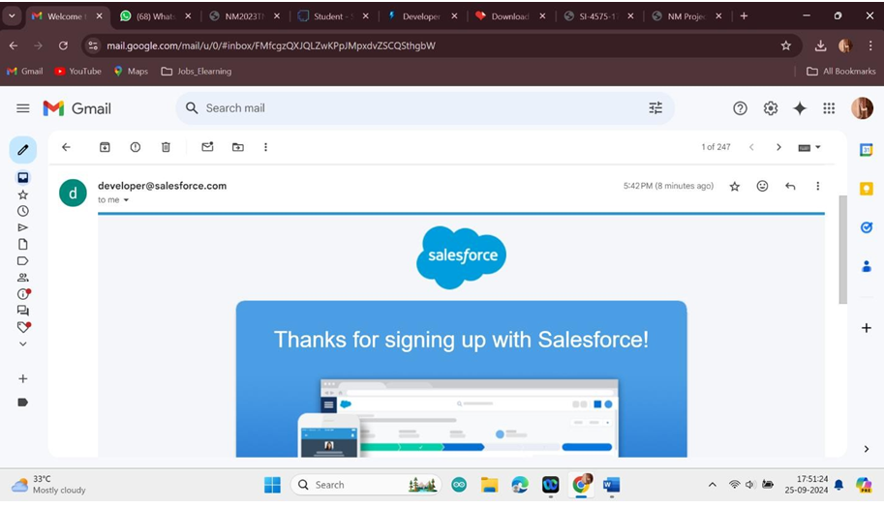

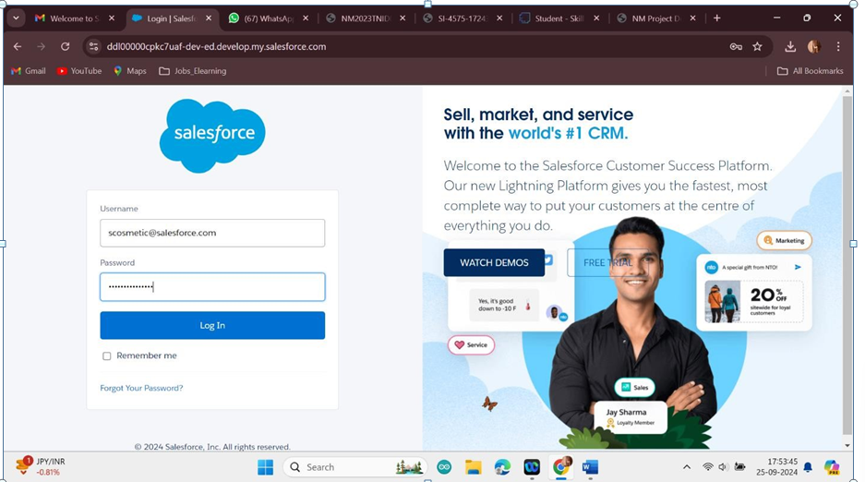

**2.Object**

Salesforce objects are database tables that permit you to store data that is specific to an organisation. Salesforce objects are of two types: Standard Objects: Standard objects are the kind of objects that are provided by salesforce.com such as users, contracts, reports, dashboards, etc.

Custom objects :Our Customers, Consultants, Retailers, Others.

**To Create an object:**

To Create an object:

Creation of Objects for Urban Color, For this Urban Colorwe need to create3 objects

i.e .,Our Customers, Consultants, Retailers, others.

The below steps will assist you in creatingthose objects.

* + Click on the gear icon and then select Setup.
  + Click on the objectmanager tab just beside the home tab.
  + After the abovesteps, have a look on the extreme right you will find a Create Dropdown click on that and select Custom Object.
  + Creation of Our Customer Object

On the Custom ObjectDefinition page, createthe object as follows:

* + Label: Our Customer
  + Plural Label: Our Customers
  + Record Name: Our Customer
  + Check the AllowReports checkbox
  + Check the Allow Search checkbox
  + Click Save.
  + Now create a custom tab. Click the Home tab, enter Tabs in Quick Find and select Tabs.
  + Under Custom ObjectTabs, click New.
  + For Object, selectOur Customer.
  + For Tab Style, select any icon.
  + Leave all defaults as is. Click Next,Next, and Save.

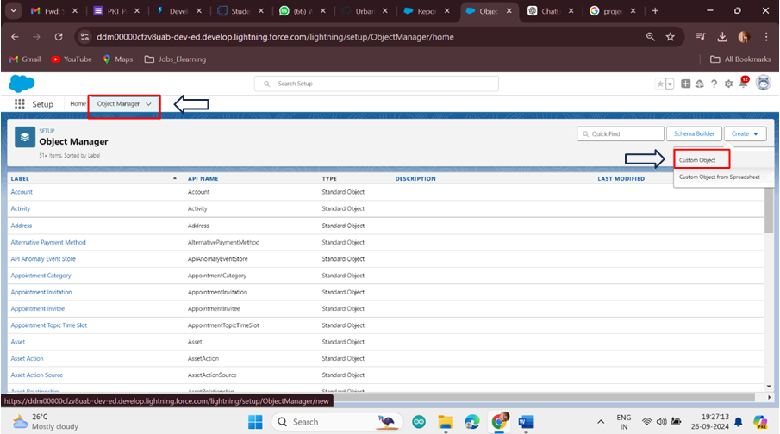

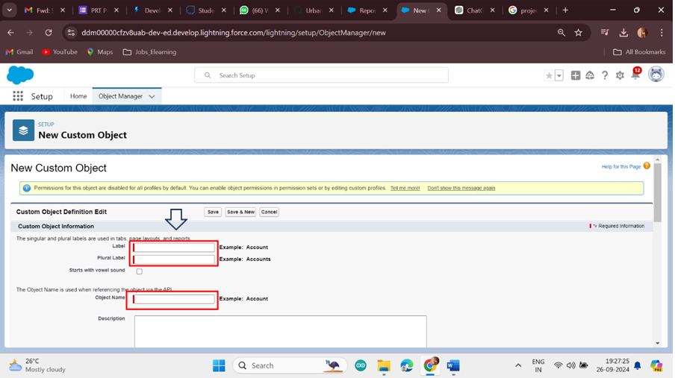

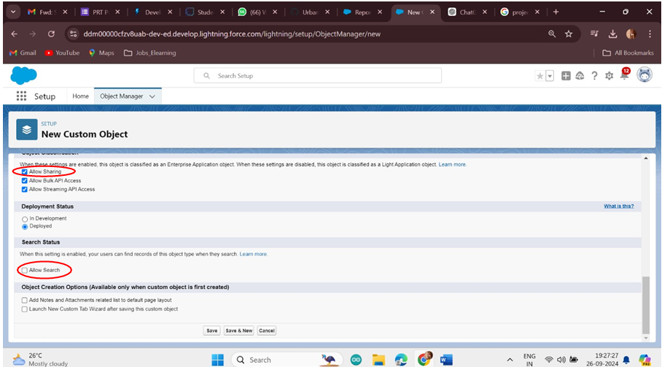

**Consultants Object Creation**

To Create an object:

The below steps will assist you in creating those objects.

* + 1. Click on the gear icon and then select Setup.
    2. Click on the object managertab just besidethe home tab.
    3. After the abovesteps, have a look on the extreme right you will find a Create Dropdown click on that and select CustomObject.
    4. Creation of Consultant Object

On the Custom ObjectDefinition page, createthe object as follows:

* + 1. Label: Consultant
    2. Plural Label: Consultants
    3. Record Name: Consultants
    4. Check the Allow Reports checkbox
    5. Check the Allow Search checkbox
    6. Click Save.
    7. Now create a custom tab. Click the Home tab, enter Tabs in Quick Find and select Tabs.
    8. Under Custom Object Tabs, clickNew.
    9. For Object, select Consultants.
    10. For Tab Style,select any icon.

Leave all defaultsas is. Click Next, Next, and Save

**Retailers object creation**

To Create an object:

The below steps will assist you in creatingthose objects.

* + 1. Click on the gear icon and then select Setup.
    2. Click on the object managertab just besidethe home tab.
    3. After the above steps, have a look on the extreme right you will find a Create Dropdown click on that and select Custom Object.
    4. Creation of RetailerObject

On the Custom ObjectDefinition page, createthe object as follows:

* + 1. Label: Retailer
    2. Plural Label: Retailers
    3. Record Name: Retailers
    4. Check the Allow Reports checkbox
    5. Check the Allow Search checkbox
    6. Click Save.
    7. Now create a custom tab. Click the Home tab, enter Tabs in Quick Find and select Tabs.
    8. Under Custom Object Tabs, clickNew.
    9. For Object, selectRetailers.
    10. For Tab Style,select any icon.
    11. Leave all defaultsas is. Click Next, Next, and Save.

**Others Object Creation**

To Create an object:

The below steps will assist you in creatingthose objects.

* + 1. Click on the gear icon and then select Setup.
    2. Click on the object managertab just besidethe home tab.
    3. After the abovesteps, have a look on the extreme right you will find a Create Dropdown click on that and select Custom Object.
    4. Creation of others Object

On the Custom ObjectDefinition page, createthe object as follows:

* + 1. Label: other
    2. Plural Label: others
    3. Record Name: others
    4. Check the Allow Reports checkbox
    5. Check the Allow Search checkbox
    6. Click Save.
    7. Now create a custom tab. Click the Home tab, enter Tabs in Quick Find and select Tabs.
    8. Under Custom Object Tabs, clickNew.
    9. For Object, selectothers.

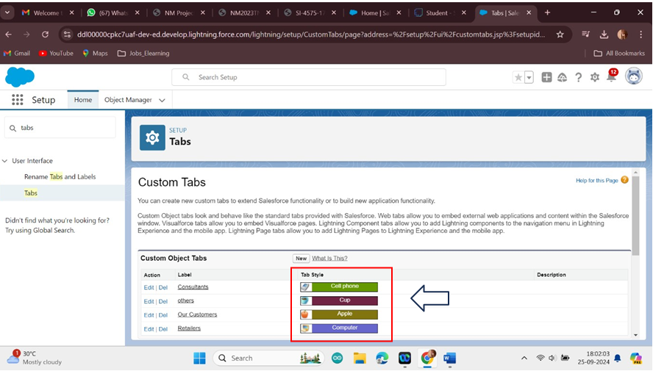

**3.Fields and Relationship**

An object relationship in Salesforce is a two-way association between two objects. Relationships are createdby creating customrelationship fields on an object.This is done so that when usersview records, they can also see and access related data.

**Fields in Our Customers objects**

Fields in Our Customers objects follow below data types:

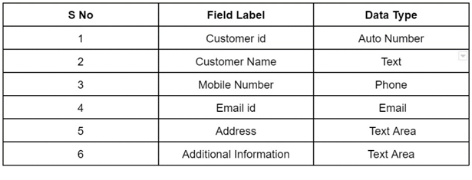

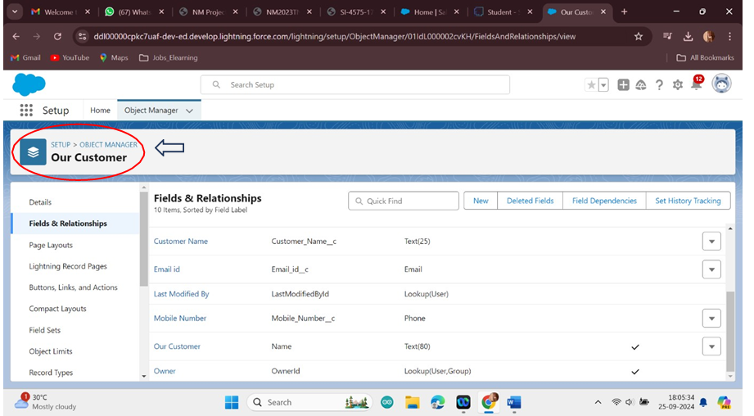

**Fields in Consultants objects**

Fields in Consultants objects follow below data types:

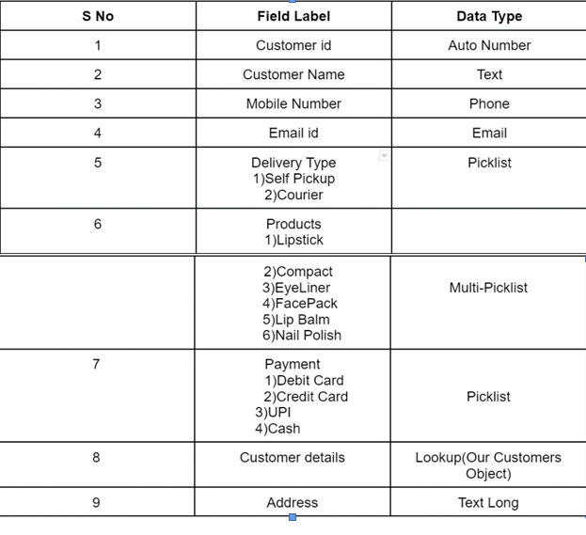

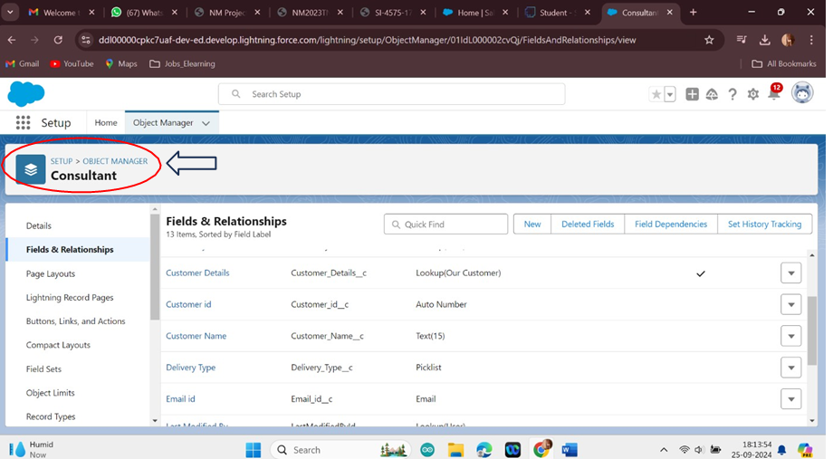

**Fields in Retailers objects**

Fields in Retailers objectsfollow below data types: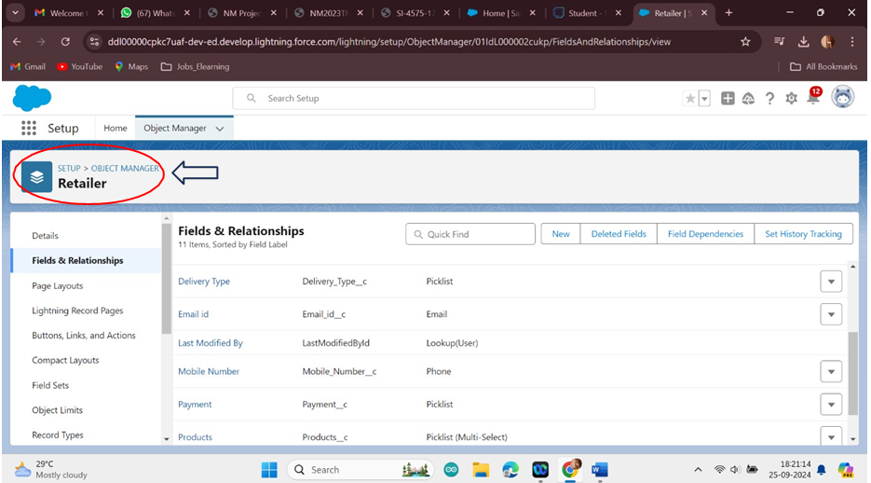

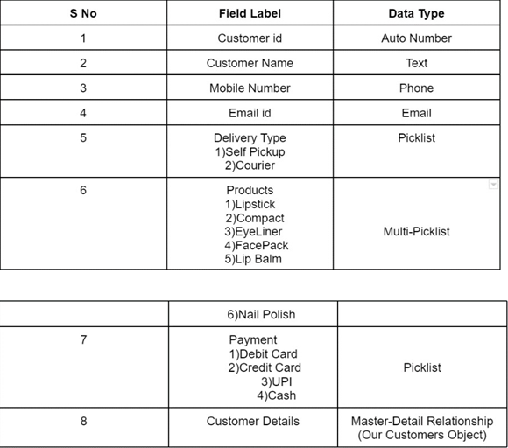

|  |  |
| --- | --- |
|  | **Fields in Others objects**  Fields in Others objects follow below data types |
|  |  |

**4.Page Layouts**

In Salesforce, page layouts definethe organisation and arrangement of fields, buttons,

related lists, and othercomponents on an object's detail and edit pages. They allow you to controlthe user interface and tailor it to meet the specific needs of your organisation.

**Page Layout Creation**

* + 1. From the Salesforce setup menu, go to "Object Manager" and select the Consultants object.
    2. Click on "Page Layouts" in the left sidebar.This will displaya list of available page layouts for the selected object.

Select the Consultant Layout page layout

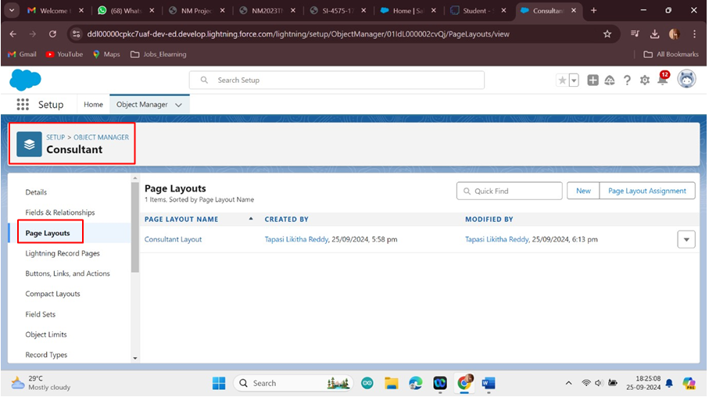

iii. Click And Drag Delivery type and AddressFields Below Phone field.

iv. Click on Save.

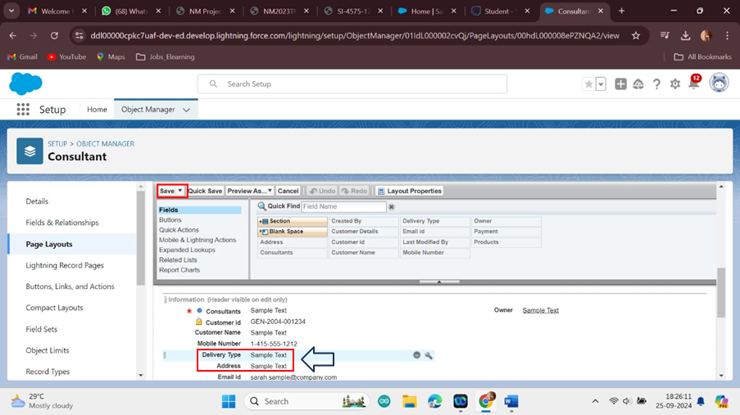

**5.The Lightning App**

An app is a collection of items that work togetherto serve a particular function.In Lightning

Experience, Lightning apps give your users access to sets of objects, tabs, and other items all in one convenient bundlein the navigation bar.

Lightning apps let you brand your apps with a custom Color and logo. You can even include a utility bar and Lightning page tabs in your Lightning app. Members of your org can work more efficiently by easily switching between apps.

**Create a Lightning App**

To create a lightning app page:

1.Go to setup page --> search “app manager” in quick find --> select “app manager” --> click on New lightning App.

2.Fill the app name as Urban Color in app details and branding --> Next --> (App option page)keep it as default --> Next -->(Utility Items) keep it as default --> Next

3.To Add Navigation Items.

4. Select the items (Customers,Consultants,Retailers,Others,Reports,Dashboards ) from the search bar and move it using thearrow button --> Next.

5.To Add User Profiles:

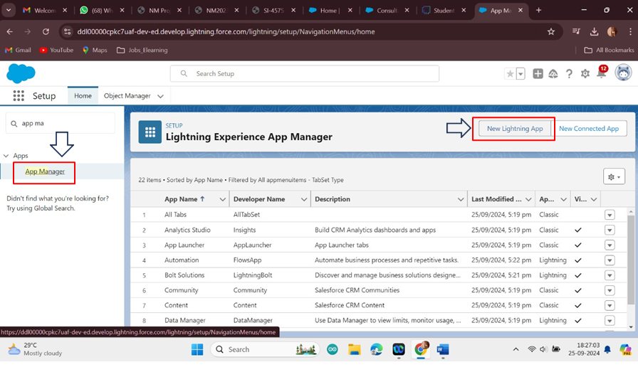

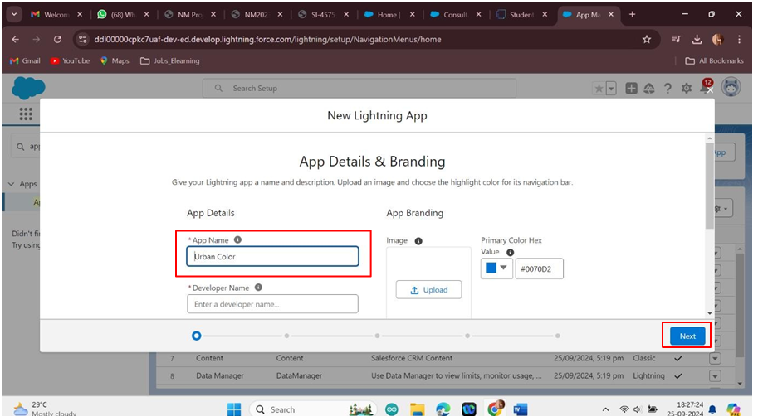

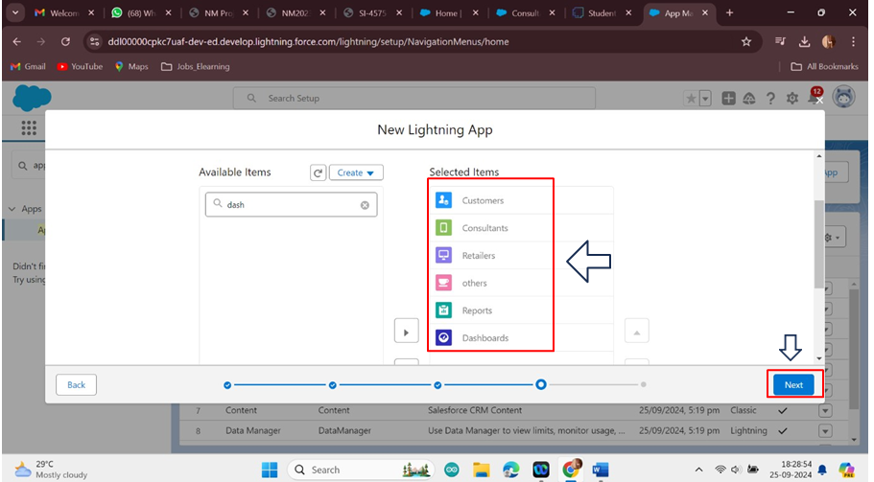

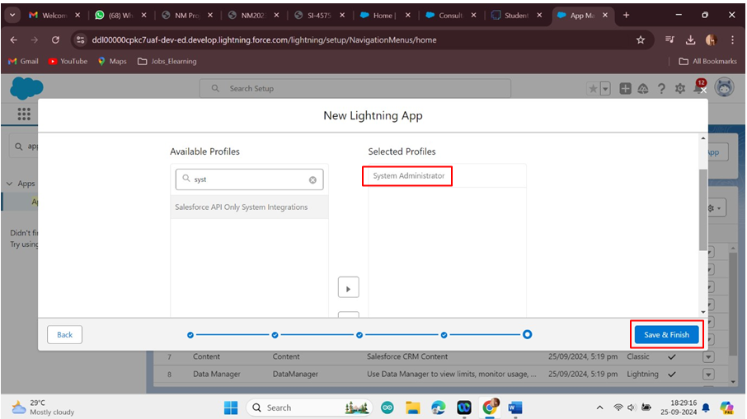6.Search profiles (System administrator) in the search bar --> click on the arrow button-> save & finish.

**6.Profile**

Aprofile is a group/collection of settings and permissions that define what a user can do in salesforce. A profile controls“Object permissions, Field permissions, User permissions, Tab settings, App settings, Apex class access, Visualforce page access, Page layouts, Record Types,Login hours & Login IP ranges.

**Creating a Profiles**

Creating a Profiles: Now create a Store Supervisor profile and set its object permissions. Creating a Profiles:

Now create a Store Supervisor profile and set its objectpermissions.

1.From Setup enter Profiles in the Quick Find box, and selectProfiles.

2.From the list of profiles, find Standard User.

3.Click Clone.

4.For Profile Name, enter Store Supervisor.

5.Click Save.

6.While still on the StoreSupervisor profile page, then click Edit.

7.Scroll down to Custom Object Permissions and give access for Create,Read,Edit,Delete,View all and modify all for Our Customers,Consultants,Retailers,Others.

8.Scroll down to Custom App Settings and give accessfor Urban Color.

To create a new profile:

1.Go to setup --> type profiles in quick find box --> click on profiles --> clone thedesired profile (standarduser is preferable) --> enter profilename --> save

2.Scroll down to the Custom objectpermission and give all access to the Consultants, Others, Our Customers, Retailers object.

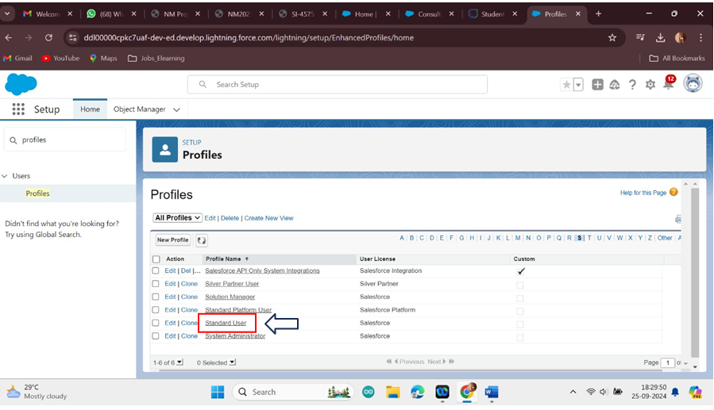

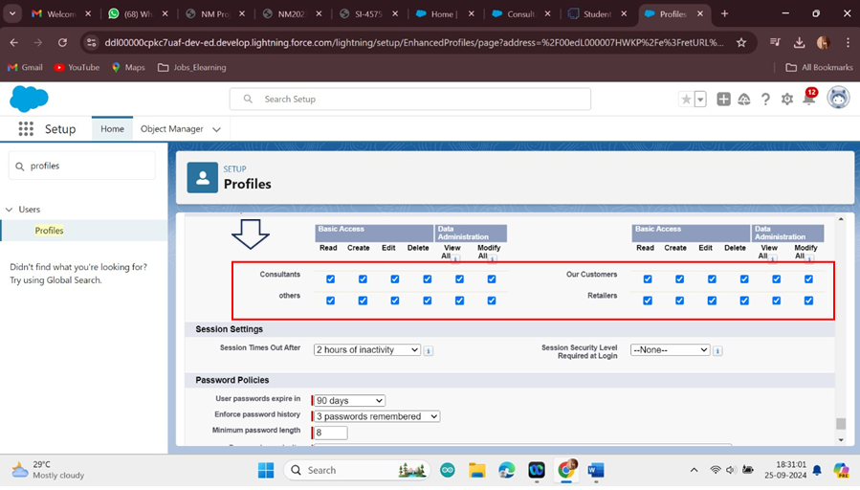

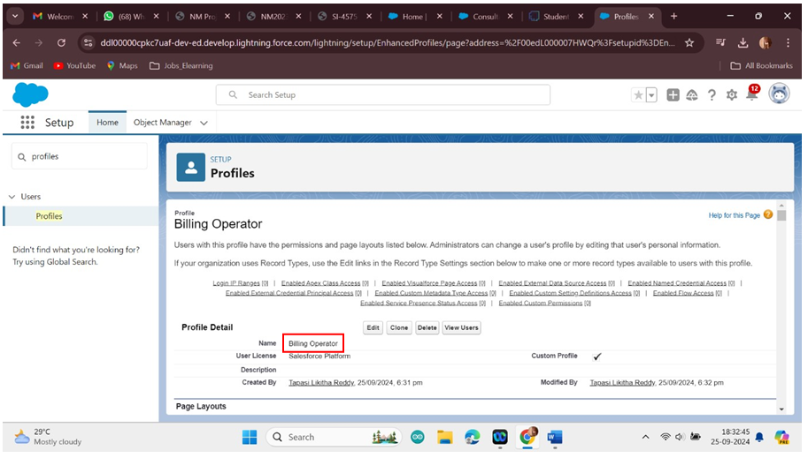

3.Click on Save.

4.Similarly Create operatorprofile ,Clone Salesforce Platform user and give accessonly for Billing Operator.

**7.Roles**

Roles are record-level access controls that define what data a user can see in Salesforce.

# 7.1.Setup Roles

1. Click on the Gear Icon

1. Click "Setup"

1. In the Quick Find box,enter "Roles"

1. Click "Roles"

1. Click on "Set Up Roles"

1. Click "Expand All"

1. Under the CEO, click on "Add Role"

1. Fill up the Label as Store Head, Role Name Store_Head.

1. Enter a Role name that will be displayedon Reports

1. Click on Save .

Similarly create One Roles under Store Head as BillingOperator.

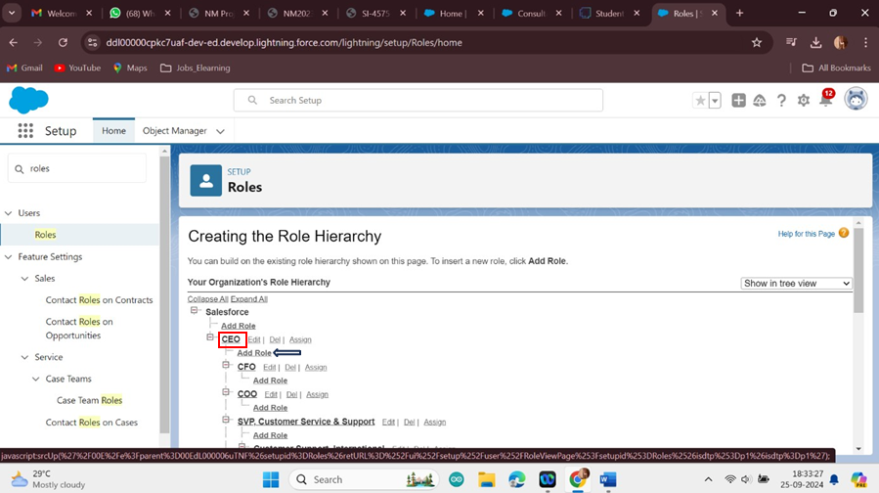

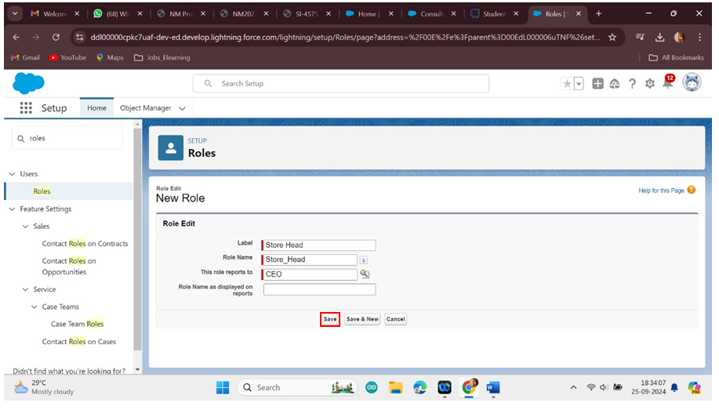

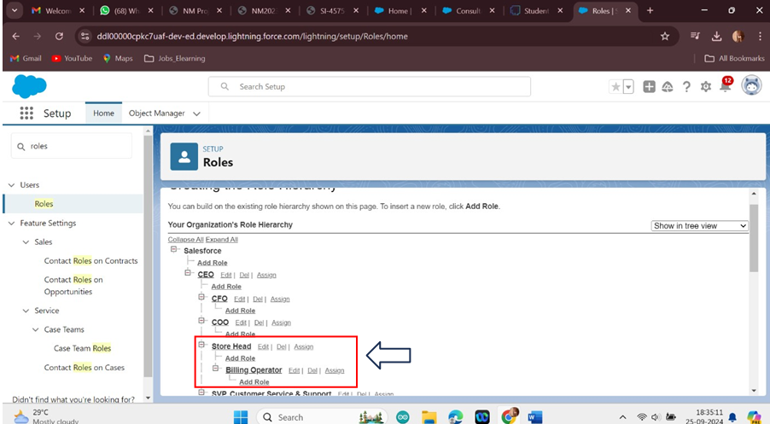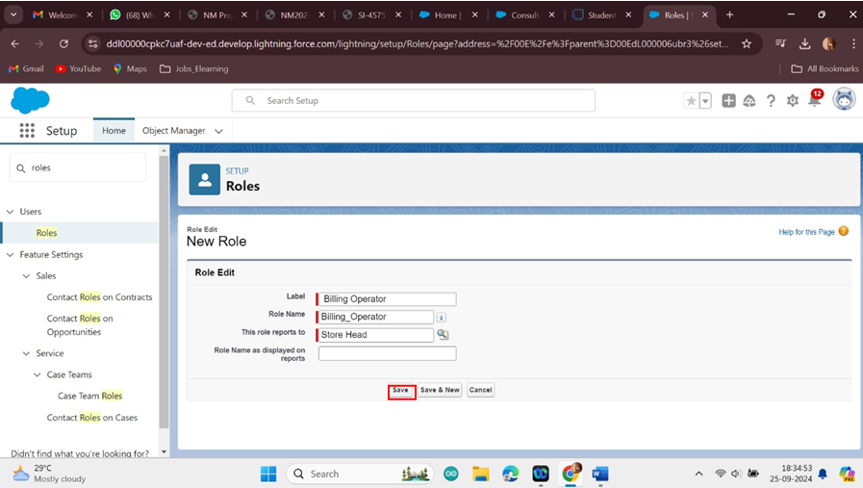

**8.Users**

A user is anyone who logs in to Salesforce. Users are employees at your company,such as sales reps, managers, and IT specialists, who need access to the company's records. Every user in Salesforce has a user account.

**Creating a Users:**

* + 1. From Setup, in the Quick Find box, enter Users, and then selectUsers.
    2. Click New User.
    3. Enter the user’s name Amar K and (Your) email address and a uniqueusername in the form of an email address. By default, the username is the same as the emailaddress.
    4. Select a Role(Store Head)
    5. Select a User Licence As Salesforce.
    6. Select a profile as Store Supervisor.
    7. Check Generate new password and notify the user immediately to have the user’s login name and a temporary passwordemailed to your email.

Fill in the fields (first name, last name, alias, email id, username, nick name, role, user licence, profiles)--> save.

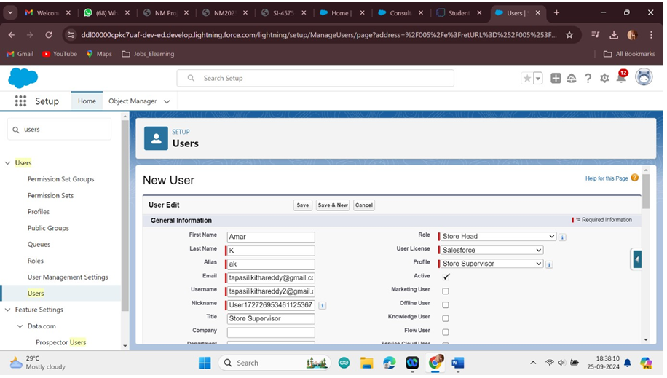

**Second User Creation**

* + 1. From Setup, in the Quick Find box, enter Users, and then select Users.
    2. Click New User.
    3. Enter the user’s name John Teddy and (Your) email address and a unique username in the form of an email address. By default, the username is the same as the email address.
    4. Select a Role(Billing Operator)
    5. Select a User LicenceAs Salesforce Platform.
    6. Select a profile as Billing Operator.
    7. Check Generate new password and notify the user immediately to have the user’s login name and a temporary passwordemailed to your email.

Fill in the fields(first name, last name, alias,email id, username,nick name, role, user licence,profiles) --> save.

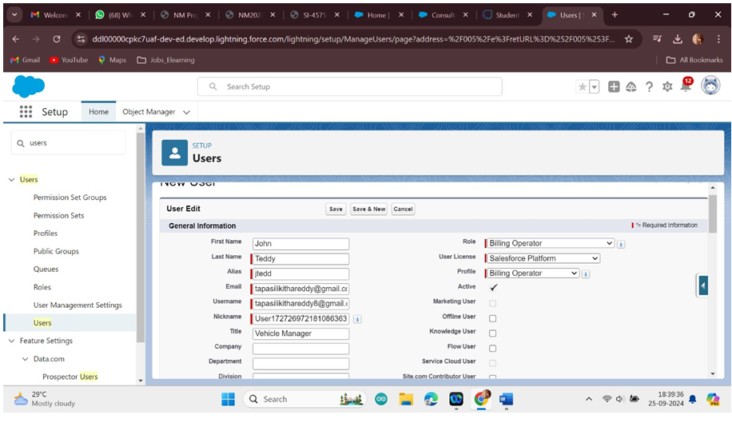

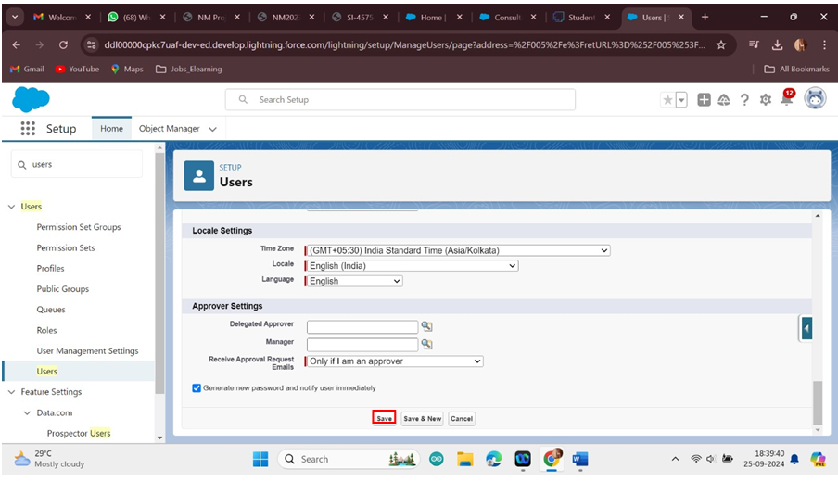

**9.User Adoption**

We need to understand user adoption and navigation. How to interact with database and their records.

**Create Our CustomerRecord**

* + 1. Click on App Launcheron left side of screen.

* + 1. Search UrbanColor & click on it.

* + 1. Click on Our Customertab.

* + 1. Click new button

* + 1. Fill all Our Customerrecord details.

* + 1. Click on Save Button

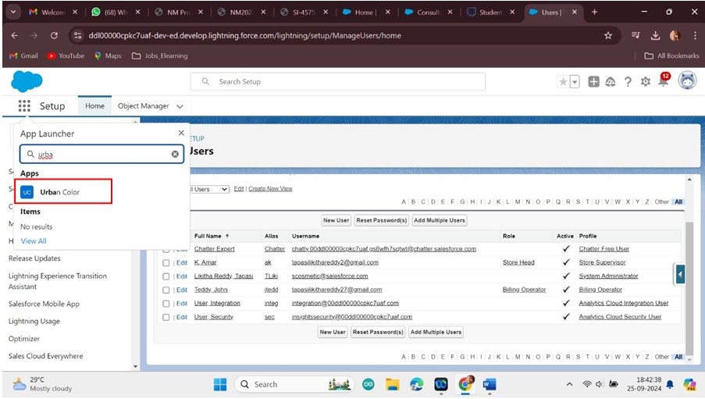

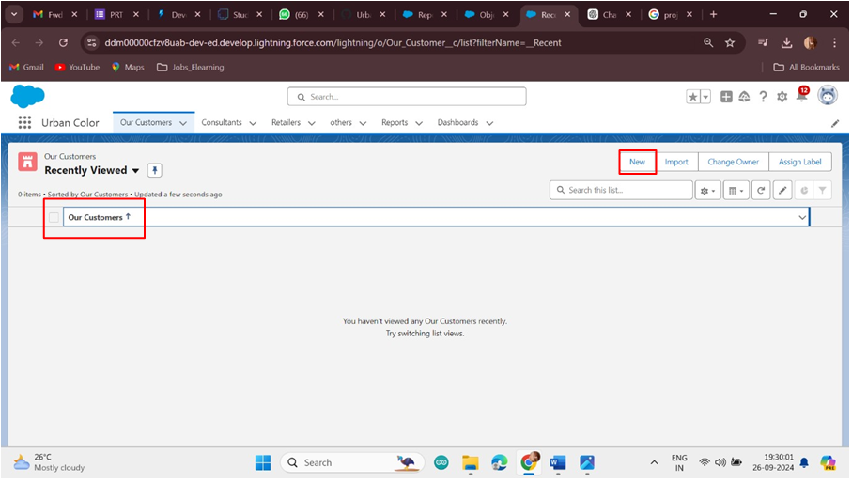

**View Record (Our Customer)**

View Record (Our Customer):

* + 1. Click on App Launcheron the left side of the screen.
    2. Search UrbanColor & click on it.
    3. Click on Our CustomerTab.
    4. Click on any recordname. you can seethe details of the Our Customer.

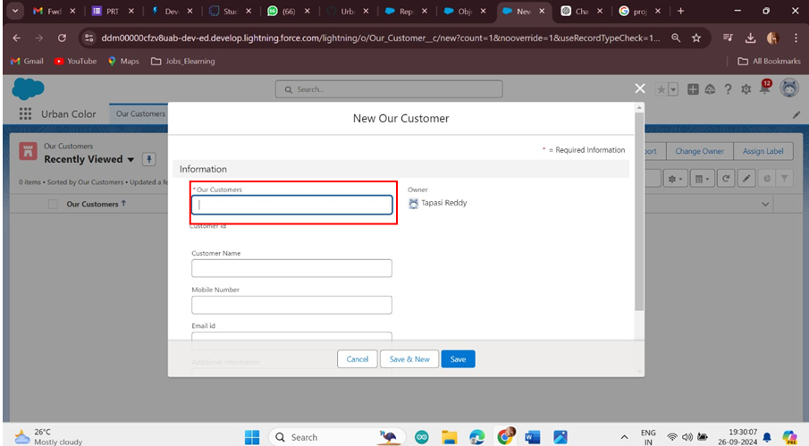

**Delete Record (Our Customer)**

Delete Record (Our Customer):

* + 1. Click on App Launcheron the left side of the screen.
    2. Search UrbanColor & click on it.
    3. Click on Our CustomerTab.
    4. Click on Arrow at right hand side on that Particular record.
    5. Click delete and deleteagain

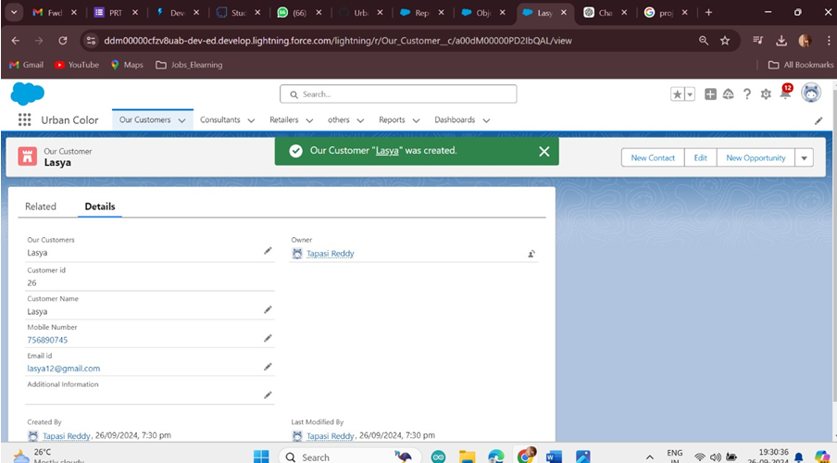

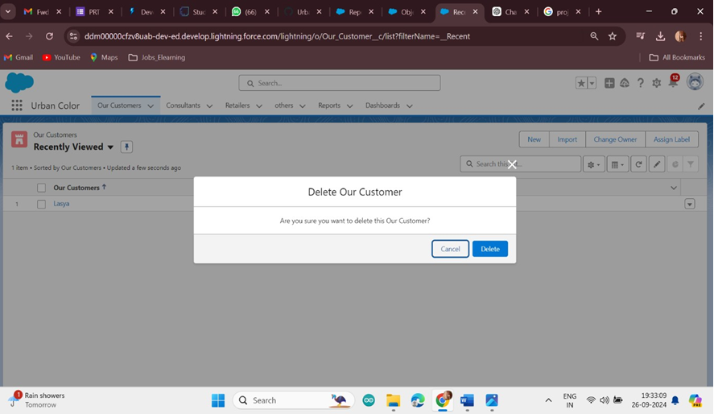

**10.Import Data**

Data Import Wizard—this tool, accessible through the Setup menu, lets you importdata in common standard objects, such as contacts, leads, accounts, as well as data in custom objects.

**To Import Data**

* + 1. From Setup, click the Home tab.
    2. In the Quick Find box, enter Data Import and select Data Import Wizard
    3. Click Launch Wizard!

iv. Click the Custom Objectstab and select the Consultant object.

v. Select Add new records.

vi. Click CSV and choose file Consultant_CSV which wemade earlier. Click Next

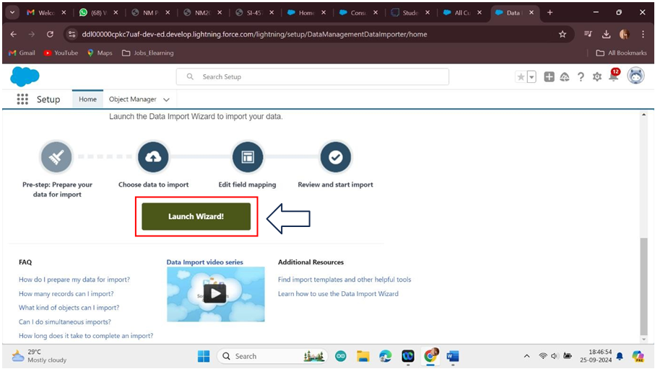

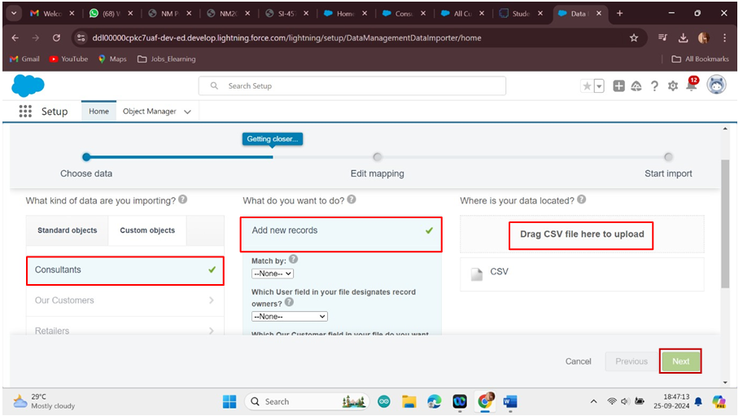

7.Since the field names in the CSV file (CSV Header) are the same as the field names in your object (Mapped Salesforce Object), the fieldsare automatically mapped.Click Next

|  |  |
| --- | --- |
|  |  |
|  |  |

8.The next screengives you a summary of your data import. Click Start Import.

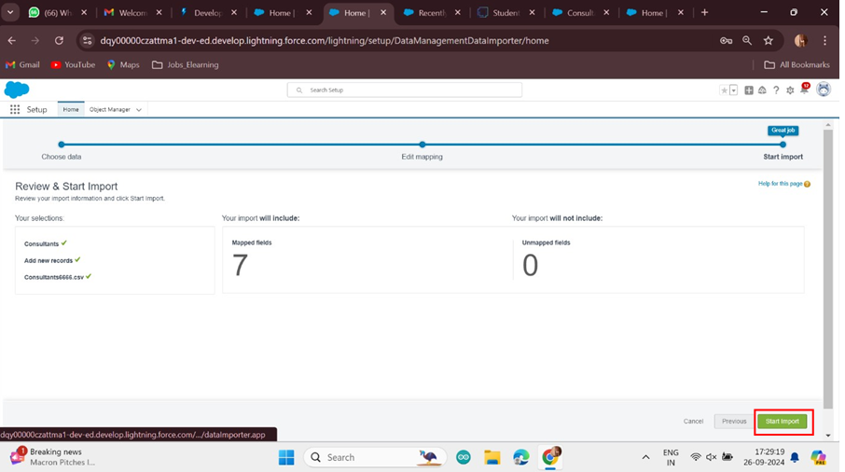

9. Click OK on the popup

|  |  |
| --- | --- |
|  |  |
|  |  |

10.Scroll down the page and verifythat your data has been imported under batches

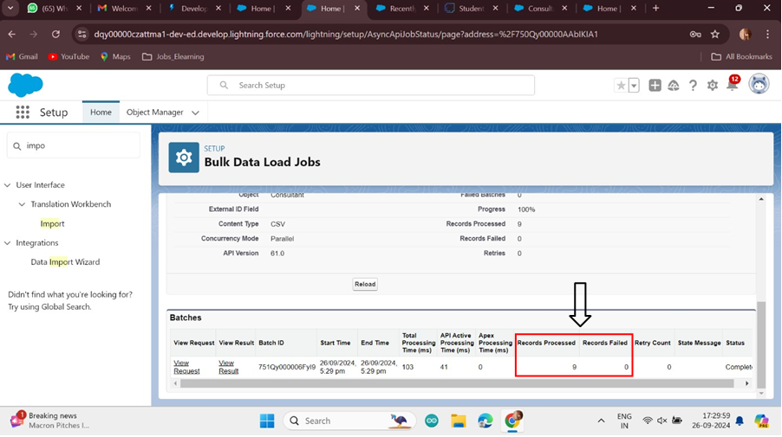

Make sure you have 0 recordsunder the recordsfailed column.

**Note** - Do Field mappingcarefully.

**11.What are Reports?**

# Reports:

Reports in Salesforce is a list of records that meet a particular criterion which gives an answer to a particular question. These records are displayed as a tablethat can be filteredor grouped based on any field.

There are 4 types of report formatsin Salesforce:

1. Tabular Reports:

This is the most basic report format. It just displaysthe row of records in a table with a grand total. While easy to set up they can’t be used to create groups of data or charts and also cannot be used in Dashboards. They are mainly used to generate a simple list or a list with a grand total.

1. Summary Reports:

It is the most commonly used type of report. It allows groupingof rows of data, view subtotal, and create charts.

1. Matrix Report:

It is the most complex report format. Matrixreport summarizes information in a grid format. It allows records to be grouped by both columns and rows. It can also be used to generatedashboards. Charts can be added to this type of report.

1. Joined Reports:

These types of reports let us create different views of data from multiple report types. The data is joined reports are organized in blocks. Each block acts as a subreport with its own fields, columns,sorting, and filtering. They are used to groupand show data from multiplereport types in different views.

# Report types:

Report type determines which set of records will be available in a report. Every report is basedon a particular report type. The report type is selected first when we create a report. Every reporttype has a primary object and one or more related objects. All these objectsmust be linked together either directly or indirectly.

* A report type cannot include more than 4 objects.
* Once a report is createdits report type cannot be changed.

There are 2 types of report types:

1. Standard Report Types:

Standard Report Types are automatically included with standard objects and also with custom objectswhere “Allow Reports”is checked.

Standard report types cannot be customized and automatically include standard and custom fields for each object within the report type. Standard report types get created when an object is created,also when a relationship is created.

**Note:** Standard report types always have inner joins.

1. Custom ReportTypes:

Custom reporttypes are reportingtemplates created to streamline the reporting process.Custom Reports are created by an administrator or User with “Manage

1. Custom Report Types” permission. Custom report types are created when standard reporttypes cannot specify which records will be availableon reports.

In custom report typeswe can specify objects which will be available in a particular report. The primary object must have a relationship with other objects present in a report type either directly or indirectly.

There are 3 typesof access levels of folders:

* 1. Viewer:

With this access level,users can see the data in a report but cannot make any changes except cloning it into a new report.

* 1. Editor:

With this access level,users can view and modifythe reports it contains and can also move them to/from any other folders they have access level as Editor or Manager.

* 1. Manager:

With this access level,users can do everything Viewers& Editors can do,plus they can also control other user’s access levels to this folder. Also, users with Manager Access levels can deletethe report.

* 1. **Create Report**

1.Click App Launcher

1. Click the report type as Consultants Click Start report.
2. Customize your report, in Columns select – Consultant Name, Delivery type, Products, Payment.
3. Click on the drop down option on the payment column and select Bucket this column.
4. Bucket Name as Paymenttype
5. Click on Add Bucket and name it as NetBanking
6. Click on Add Bucketand name it as Cash
7. Now Click on All Values and select Credit Card, Debit Card, UPI and Move to Net Banking.
8. Now Click on All Values again and select Cash and Move to Cash.
9. Click on Apply.

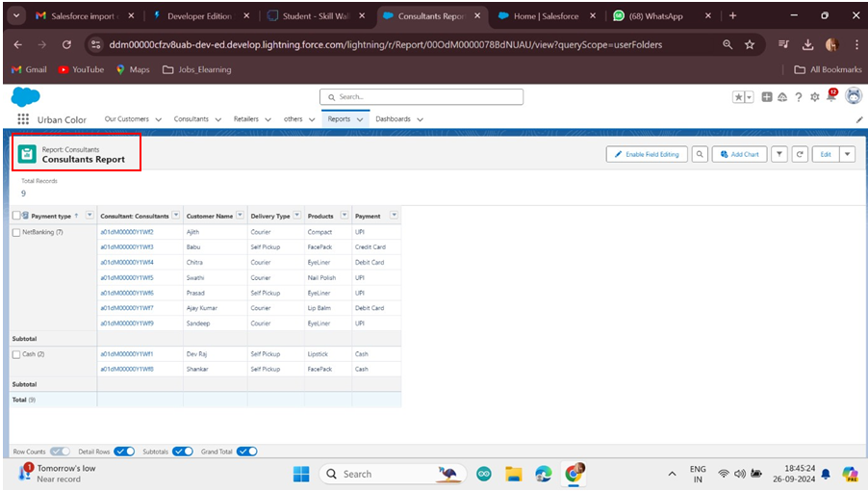

.In Group Rows Add Payment Type Bucket Field. 15.Click refresh

1. Click Save and Run

2.Give report name – Consultant report

Click Save.

**View Report**

* + 1. Click on App Launcher on the left side of the screen.
    2. Search Urban ColorApp & click on it.
    3. Click on ReportsTab.

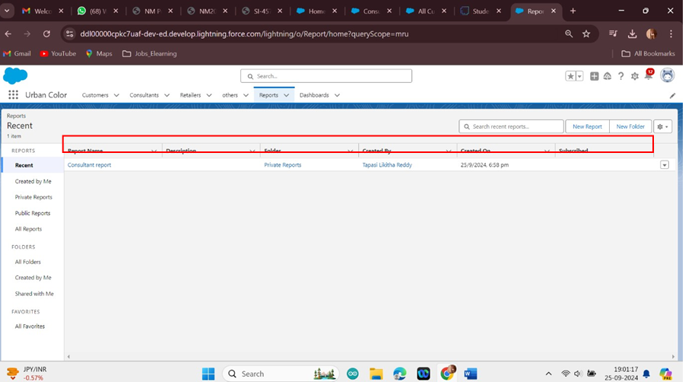

**12.Dashboards**

Dashboards let you curate data from reports using charts, tables,and metrics. If your colleagues need more information, then they're able to view your dashboard's data supplying reports. Dashboard filters make it easy for users to apply different data perspectives to a single dashboard.

**Create Dashboard**

* + 1. Click on the Dashboards tab from the Urban Color application.
    2. Click on the new dashboard.
    3. Give name- Consultant Dashboard
    4. Click create
    5. Give your dashboard a name and click on +component
    6. Select the Consultants Reportwhich you created.
    7. For the data visualization select any of the chart,table etc. as per your choice/requirement.
    8. Click add.
    9. Click save.
    10. Click save.

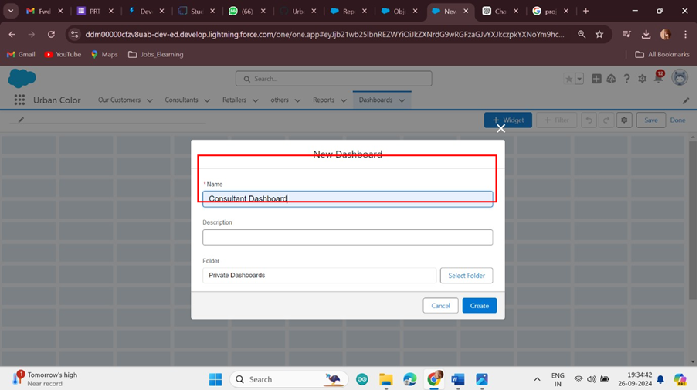

|  |  |
| --- | --- |
|  |  |
|  |  |

**View Dashboard**

* + 1. Click on App Launcher on the left side of the screen.
    2. Search Candidate InternalResult Card & click on it.
    3. Click on Dashboard Tab.

iv. Click on Candidate Internal Result Card see graph view of records